Project – Landing Page Documentation - Personal Portfolio Website
GitHub Live URL –


Pagination
Number of Web Pages – 1 (Landing Page)

Production Tools
Visual Studio Code
Frontend-HTML, CSS-Tailwind, JavaScript.

Application Type
Micro Blogging Web page

Sightings Included
- Screenshots
- Descriptions and Summary
- Workflows
- More details

PURPOSE OF DOCUMENT
- Technical Support
- Programming team
- Intellectual Property Filing
- Trade Mark Purposes
- Copyright Purposes
- Other Miscellaneous Purposes

LANDING PAGE
1.10 Menu Section
1.20 Hero Section
1.30 About Me Section
1.40 Skills Section
1.50 Services Section
1.60 Projects Section (Featured Work)
1.70 Contacts Section (Let’s Work Together)
1.80 Footer Section

1.10 MENU SECTION
Overview
This section is situated at the topmost part of the landing page. It covers a 100% width of the landing page and about 10% of the total landing page height. It has a background color of Black.

1.1.10 Profile logo name (Samuel.), white bold text situated at the left hand end of the menu bar. The menu bar has a thing cayen-400 bottom border line of about 1px, also spans a 100% width of the page, and to the right hand side of the menu bar consists of Five page sections navigation links, written in white text semi bold font, and these sections links include:-
    - Home
    - About
1.1.40 Skills
1.1.50 Services
1.1.60 Projects
1.1.70 Contacts

Menu section screenshot:-

1.20 HERO SECTION

Overview
This section sits below the Menu section, it has a Black background, and it covers about 85% width of the screen. Split into two halves, the left half consists of a block of texts, and three link buttons to different sections of the page, and on the right half of the hero section sits a profile image.
To the left:-
1.2.10 A block of texts that consists of a greeting text (all caps and cayen-400 color), authors name (first letter caps, bold text, white and cayen-400 color mix), role (first letter caps, bold text, cayen-400 color), expertise summary text (small font text size, color white, slightly faded).
1.2.20 View Projects button, background color cayen-300, white text, outline none, navigates to Featured Work page section.

1.2.30 Download CV button, background color black, white text, 1px outline border of color Cayen-400. Auto downloads a Pdf CV file upon click.

1.2.40 Hire Me button, background color black, white text, 1px outline border of color Cayen-400. Navigates to Contacts section upon click.

To the right:-
1.2.50 A profile image, full rounded with a centered image of the author, about 2px rounded border of color Cayen-400.

Hero section screenshot below:-
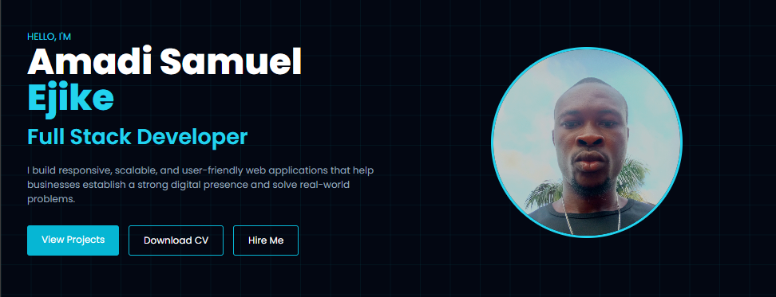

1.30 ABOUT ME SECTION

Overview
This section sits below the Hero section, it has a Black background, and it covers about 85% width of the screen. Split into two halves, the both halves consists of block of texts.
To the left:-
1.3.10 A block of text with a summary text about the author, small text font, color white, slightly faded.

To the right:-
1.3.20 A block of texts and number further split into a grid of two column and two rows (4 blocks), of small texts and semi large font numbers of color cayen-400.

About me section screenshot:-
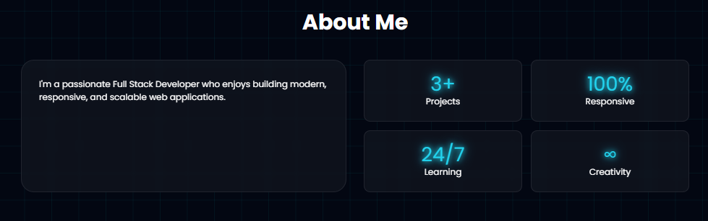

1.40 SKILLS SECTION

Overview
This section sits below the About Me section, it has a Black background, and it covers about 85% width of the screen. With just a single bloc of text.

1.3.10 A block of text white color that uses a range indicator (gradient color of 45deg cayen-400 to cayen-200) to show the range of a parameter within the 100% level range mark.

Skills section screenshot:-
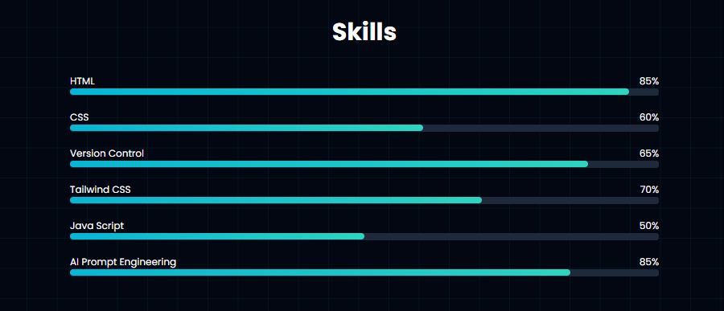
1.50 SERVICES SECTION

Overview
This section sits below the Skills section, it has a Black background, and it covers about 85% width of the screen. With just a single block split into two rows and three columns (5 sub-blocks).

1.5.10 Five identical blocks of text in two rows and three columns grid, with caption texts of color cayen-400, and normal white color text fonts.

Service section screenshot:-
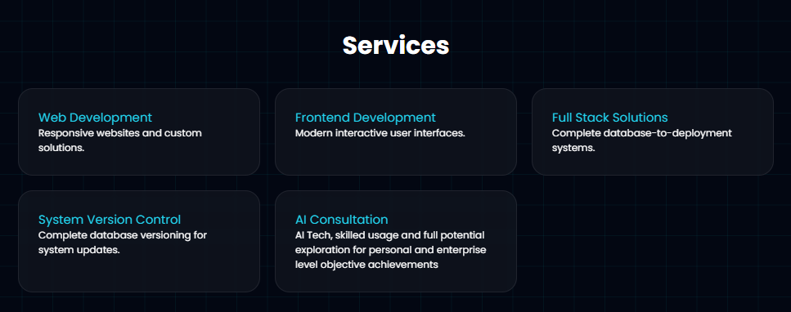

1.60 PROJECTS SECTION (FEATURED WORK)

Overview
This section sits below the Services section, it has a Black background, and it covers about 65% width of the screen. This section is split into two blocks stacked vertically together.

1.6.10 First, a block of paragraph text, white colored and slightly faded text.

1.6.20 Second, a block with three video cards vertically stacked on each other, with a play/pause button at the top center with a hover scale effect of 1.01 for each card.

Projects Section (Featured Work) screenshot below:-
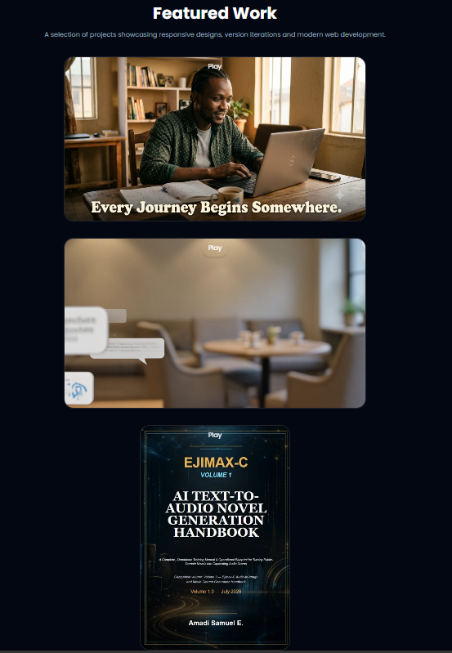

1.70 CONTACTS SECTION (LET’S WORK TOGETHER)

Overview
This section sits below the Projects section, it has a Black background, and it covers about 55% width of the screen. This section is divided into two vertically stacked blocks.

1.7.10 First block, an email linked button, with a background color of cayen-300 small rounded edges with no outline/border.

Second block, consists of three horizontally aligned social link buttons.
1.7.20 Github link button, black background, white text and icon, no outline/border.

1.7.30 LinkedIn link button, black background, white text and icon, no outline/border.

1.7.40 X/twiter link button, black background, white text and icon, no outline/border.

Contacts section (let’s work together) screenshot:-
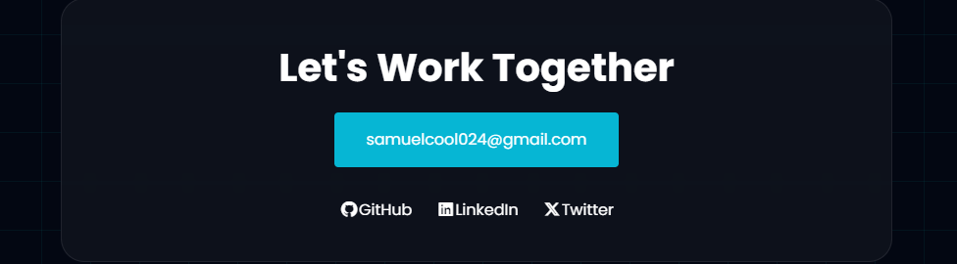
1.80 FOOTER SECTION
Overview
This section is situated at the bottom part of the landing page. It covers a 100% width of the landing page and about 10% of the total landing page height. It has a background color of Black.

1.8.10 A block of copyright text, white color, properly aligned at the center of the footer section. The footer bar has a thing cayen-400 top border line of about 1px, also spans a 100% width of the page.

Footer section screenshot:-
